Elizabeth Pozzulo
Graph Yourself!

Goals:
The student will learn how to graph a line when presented with a linear equation.
The student will learn how to determine which lines will have steeper slopes.

Objectives:
Given an equation of a line in the form $y=mx+b$, the student will graph 5 consecutive lines correctly.
Given two linear equation in the form y=mx+b, the student will correctly state which one will have a steeper slope 5 consecutive times.

Materials:
- Duct Tape
- Worksheet

Step One: Put two pieces of tape on the floor (one for the x-axis and one for the y-axis).
Step Two: Label the x-axis, then label the y-axis.
Step Three: Ask the students to find the y-intercept. Once they have found it, have one student “graph” his/herself on that point.
Step Four: Tell the students to determine the slope. Once everyone has found it, choose at least two more students to “graph” themselves (while the other student is still there).
Step Five: Repeat the process multiple times.
Step Six: After two or three examples, have the students determine which lines are steeper. They should be able to generalize that lines with higher coefficients in front of the “x” (a bigger slope) will produce a steeper line.

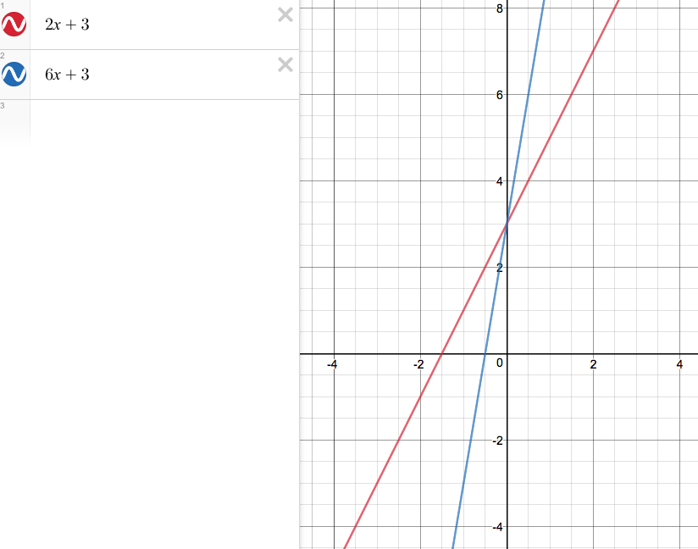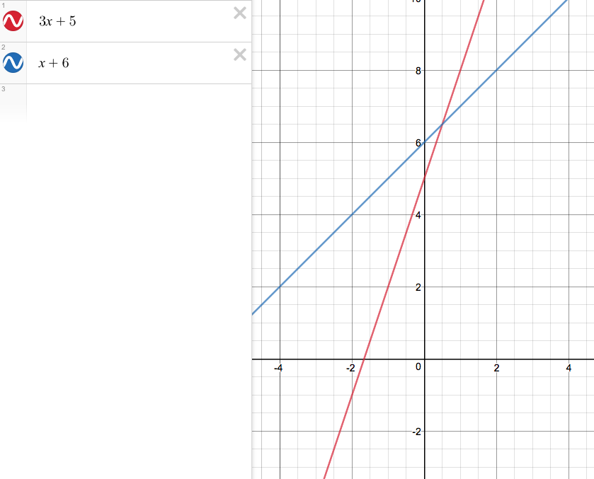

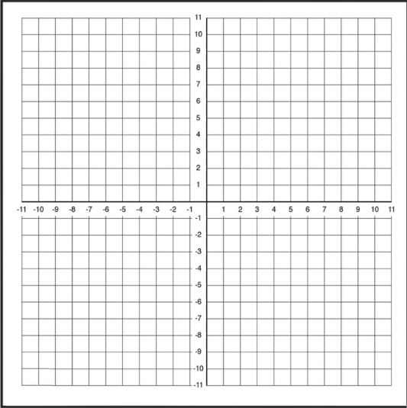
- Graph the line y=2x+3
Y-intercept: _______
Slope: ________

- Graph the line y=6x+3
Y-intercept: ________
Slope: ___________

- Graph the line y=3x+5
Y-intercept: ________
Slope: __________

- Graph the line y=x+6
Y-intercept: ________
Slope: _________

