Elizabeth Pozzulo
MTH 4040 Coordinating Seminar
Technology Presentation
Equilateral Triangles
- Open a new Geogebra file. Before you do anything, right click anywhere on the graph and press “Axes” to get the x and y-axis and “Grid”, so it’s easier to plot points.
- Click on the arrow in the bottom right corner of the third icon and select “Segment”. Then draw a line segment starting at the point (0,0) and ending at (6,0) like the example below:

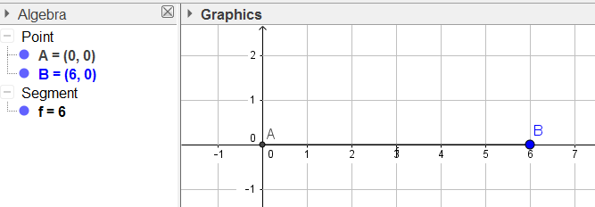

- Click on the arrow on the bottom right corner of the sixth icon (it should be a circle), then select “Circle with Center through Point”. Click on Point A, then click on Point B to create a circle where A is the center and the line segment AB is the radius of the circle.

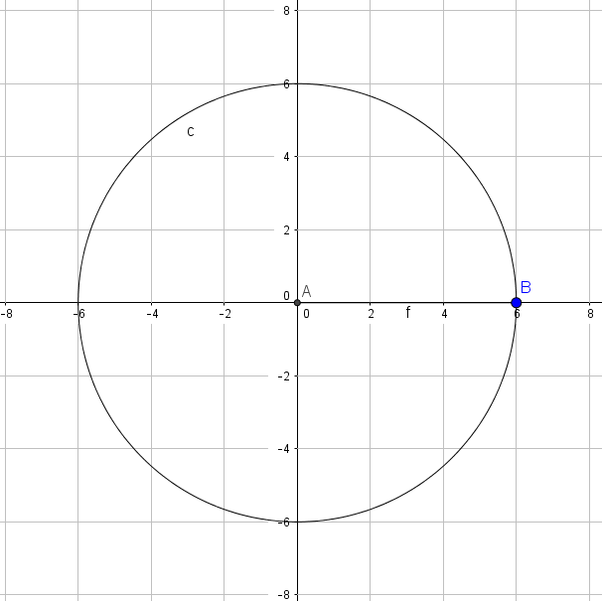
- Now create a second circle starting at Point B and going to Point A, so point B is now the center and the line segment AB is still the radius.

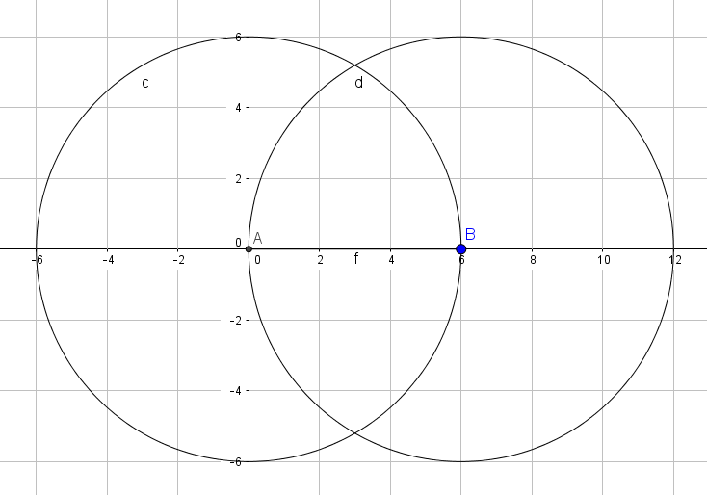
- Go back to the third icon to create a line segment that goes from Point A to where the circles intersect on top. Then create another line segment going from Point B to the top, which is now labeled as Point C. Now you should have a triangle within the intersections of the two circles.

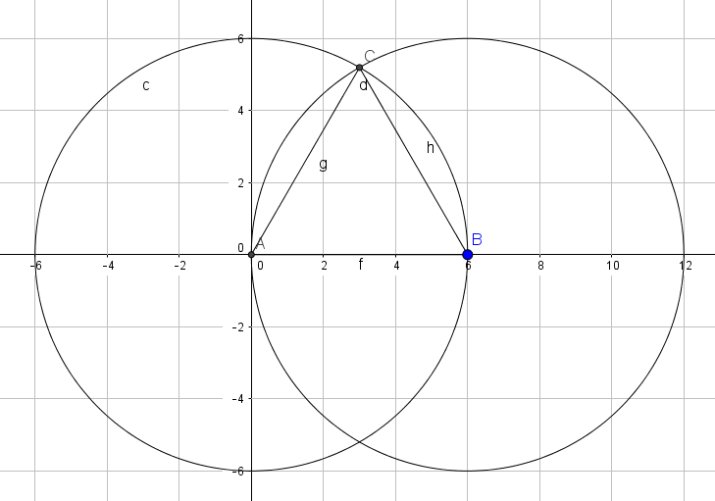

- Now you have an equilateral triangle. Select the first icon, the cursor, so you can move the triangle and circles around. No matter how big or small you make the triangle, it’ll always be equilateral.

Now that you’ve created an equilateral triangle, complete the following:
- Why will the triangle always be equilateral regardless of the size you make them?
- Using a ruler and a compass, create the circles and equilateral triangle.
- Conduct a proof to show that our original triangle is an equilateral triangle.

